Ecommerce API documentation

Contents
1. Overview
2. Authentication
  - Basic authentication

3. Resources
  - Users
  - Customers
  - Sellers

  - Products
  - Carts

1. Overview
This documentation describes how to use the Ecommerce App Rest API Requests to
retrieve or manipulate the data in Ecommerce system. This Ecommerce API is based on Basic HTTP Autentication.

2. Authentication
This authentication scheme uses HTTP Basic Authentication, signed against a user's username and password. If successfully authenticated, Basic Authentication provides the following credentials.
Unauthenticated responses that are denied permission will result in an HTTP 401 Unauthorized response with an appropriate WWW-Authenticate header.

3. Resources
The API is RESTful and arranged around resources.

Users

POST Sign up
The ecommerce Customer Sign up
http://127.0.0.1:8000/ecommerce/customer/register
In the body We should pass the data

{
"first_name":"Anyaaa",
"last_name":"Dhilipi",
"username":"yuvaraj",
"email":"yuvarajyui@gmail.com",
"password":"kaviyas12344",
"phone": "9132356003",
"sex":"f",
"address":"12/45,Jino colony,Hydrabad , India"
}

The ecommerce Seller Sign up
http://127.0.0.1:8000/ecommerce/seller/register

In the body We should pass the data

{
"first_name":"qazwsx",
"last_name":"ij",
"username":"karthick",
"email":"karthi@gmail.com",
"password":"yuvarajkeerthu",
"phone": "9278200130",
"sex":"F",
"address":"12/45,hemni colony,Delhi , India"
}

Returns the success message when signed up successfully or returns the Error message.
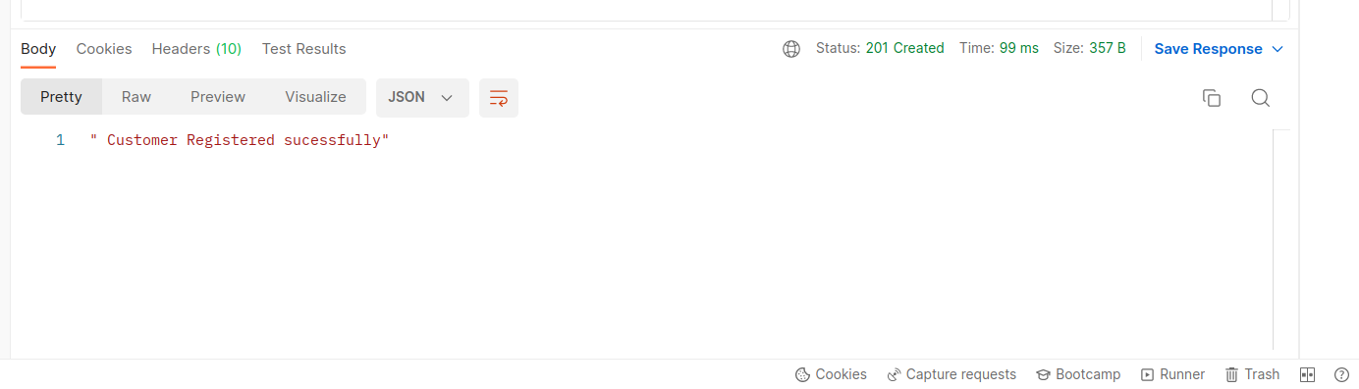
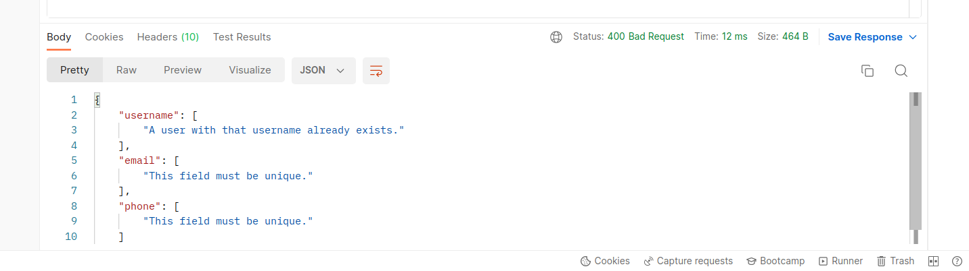

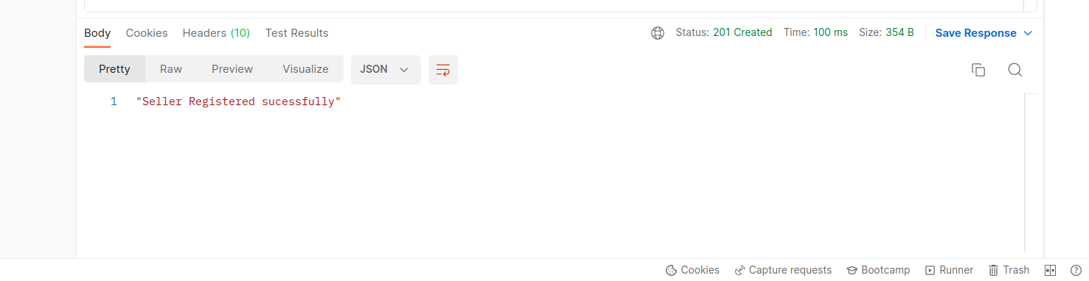

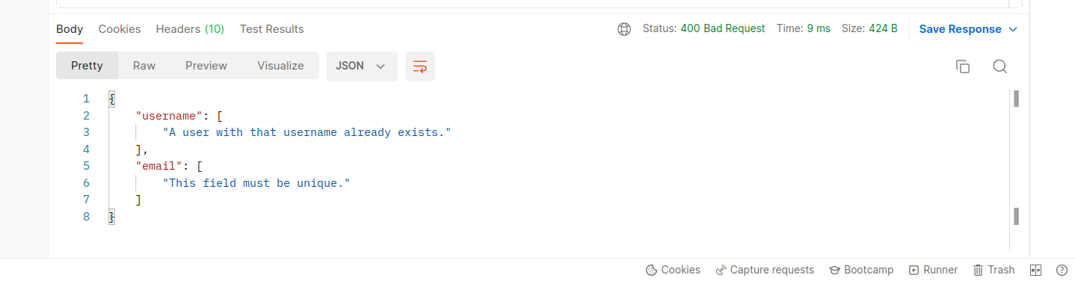

Where a User object is:
Field | Type | Description
id | integer | A unique identifier for the user.
firstname | string | The user’s firstname.
lastname | string | The user’s lastname.
username | string | The user’s username on Ecommerce app.
email | string | The user’s email id on Ecommerce app.
password | string | The user’s password

Possible status codes:
Status code | Description
201 Created | When the user is signed up successfully.
400 Bad request | When the user is not signed up.
POST Sign in
Sign in for the Ecommerce users
http://127.0.0.1:8000/ecommerce/login

username:"gayu",
password:"zxcvbnml",
Returns the user details if signed in sucessfully.
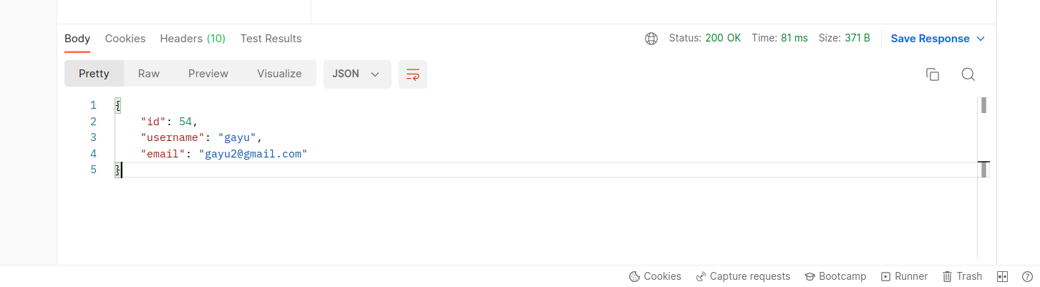

Returns the Error message if signing in fails.

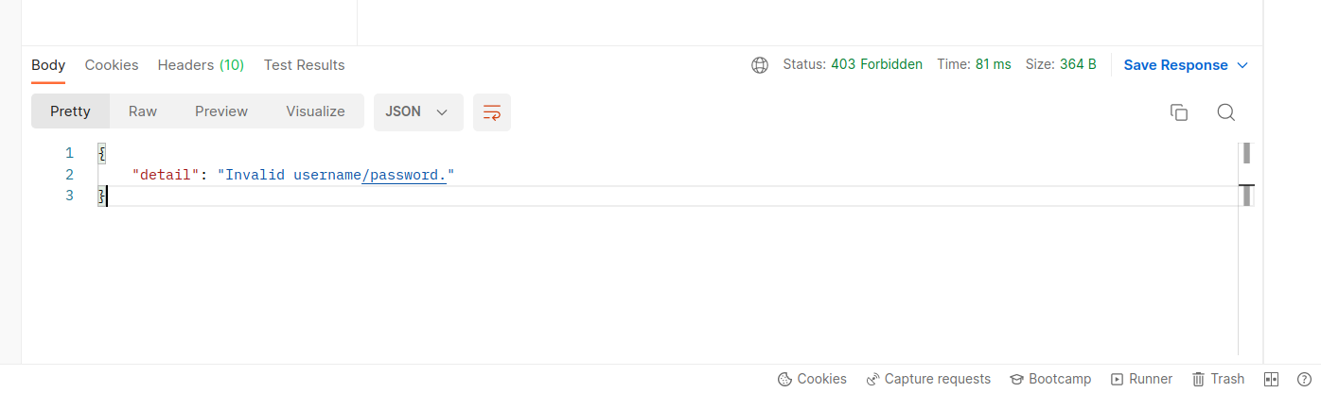

Where a User object is:
Field | Type | Description
username | string | The user’s username on Ecommerce app.
password | string | The user’s password

Possible status codes:
status code | Description
200 Ok | When the user is signed in successfully.
403 Forbidden | When the user is not signed in.

Products

GET Products
Listing all the available products in the ecommerce site.
Returns a full list of products of all the seller.
A request to fetch a list of products looks like this:
GET http://127.0.0.1:8000/ecommerce/product
The response is a list of products objects. An empty array is returned if there are no products available. The response array is wrapped in a data envelope.
Example response:
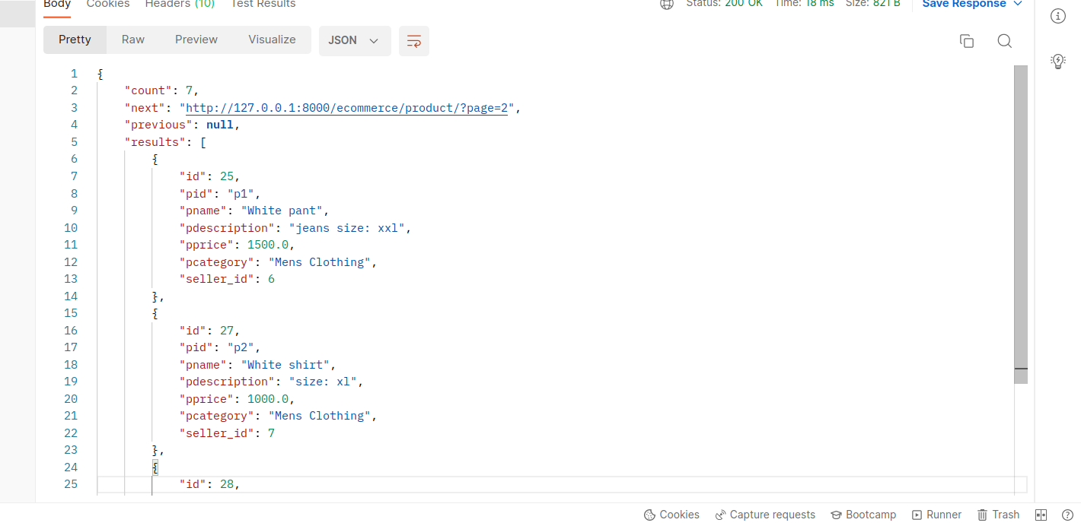

Possible status codes:
status code | Description
200 Ok | When the user is signed in successfully.

GET Product by ID
Retrieve a specific product by its ID
An example request looks like this:
GET http://127.0.0.1:8000/ecommerce/product/pid?pid=p1
where pid is the product ID.

Example of some product ID’s:
P1, P2, p2, qazd12, QWER13
An example response looks like this:
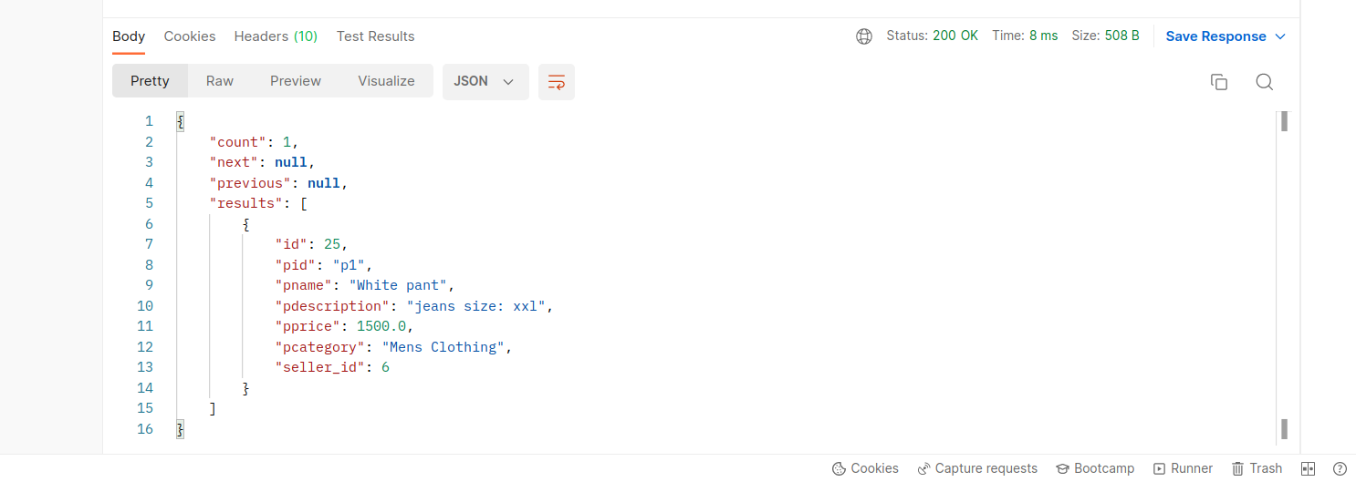

Returns a empty list if product not found.

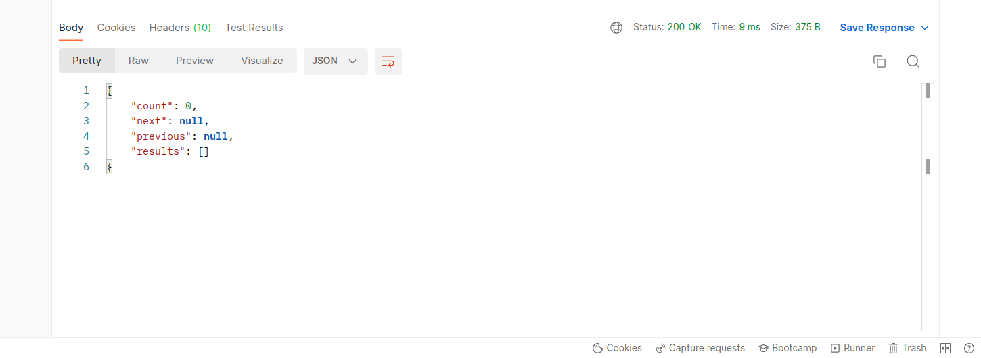

Possible status codes:
status code | Description
200 Ok | When the user is signed in successfully.
404 Not Found | When the product is not found.

GET Product by Categories
Retrieve the product by categories. Returns the products matching the category else returns the empty list.
An example request looks like this:
http://127.0.0.1:8000/ecommerce/product/category/?category=Mobile
where category is the product category.
Some category examples: Mobile , plastice , Mens clothing
An example response looks like this:

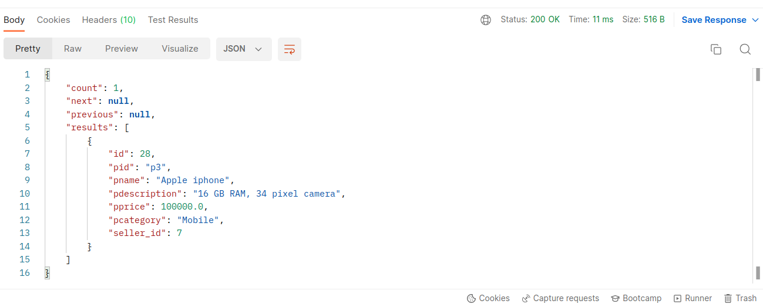

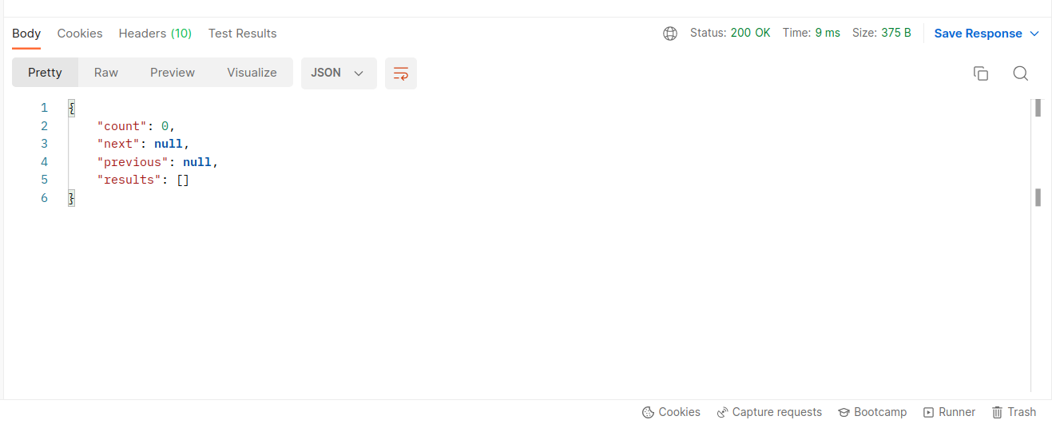

Possible status codes:
status code | Description
200 Ok | When the user is signed in successfully.
404 Not Found | When the product is not found.

POST Products

The authenticated sellers can post their products.
An example request looks like this:
http://127.0.0.1:8000/ecommerce/seller/product/add

{
"pid":"p8",
"pname":"water bottle",
"pdescription":" eco friendly platic water bottle",
"pprice":99,
"pcategory":"plastics"
}

An example response looks like this:
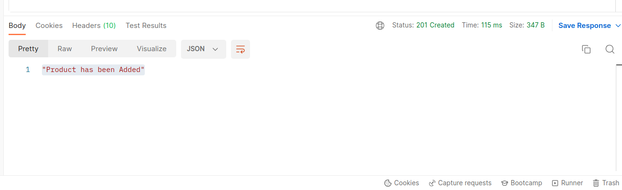
Where a Product object is:
Field | Type | Description
id | string | A unique identifier for the publication.
pid | string | A unique product ID.
name | string | The product’s name on ecommerce.
description | string | Short description of the product.
price | string | The product’s price.
Seller id | string | The id of the product’s seller.

status code | Description
201 Created | When the product is added successfully.
400 Bad request | When the product is not created.
PUT update products
The authenticated sellers can update their products details.
An example request looks like this:
http://127.0.0.1:8000/ecommerce/seller/product/update?pid=p7
where pid is the product ID of the product to be updated.
Examples of some Product Ids : p1,p23,P90,KLO90,M90J
The data values are sent through body
{
"pid": "p7",
"pname": "White pant",
"pdescription": "jeans size: xxl",
"pprice": 1500.0,
"pcategory": "Mens Clothing",
"sellerid": 6
}

An example response looks like this:
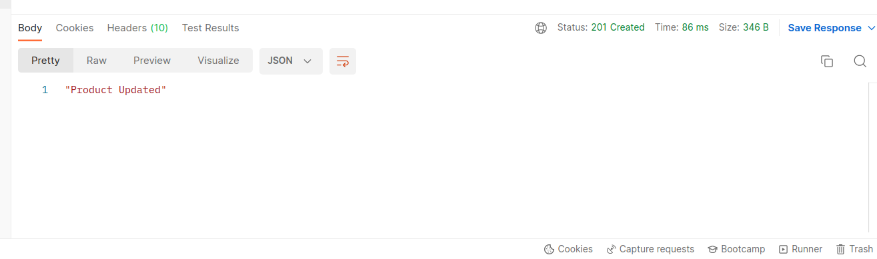

Where a Product object is:
Field | Type | Description
id | string | A unique identifier for the publication.
pid | string | A unique product ID.
name | string | The product’s name on ecommerce.
description | string | Short description of the product.
price | string | The product’s price.
Seller id | string | The id of the product’s seller.

possible status code:
status code | Description
201 Created | When the product is added successfully.
400 Bad request | When the product is not created.
403 Forbidden | When the seller tries to update other’s product
404 Not found | When the product id no found.
DELETE Product
The authenticated sellers can delete their products.
An example request looks like this:
http://127.0.0.1:8000/ecommerce/seller/product/delete?pid=p2
where pid is the product ID of the product to be deleted.
Examples of some Product Ids : p1,p23,P90,KLO90,M90J
An example response looks like this:

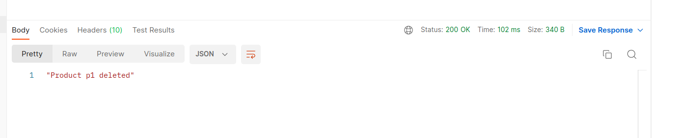

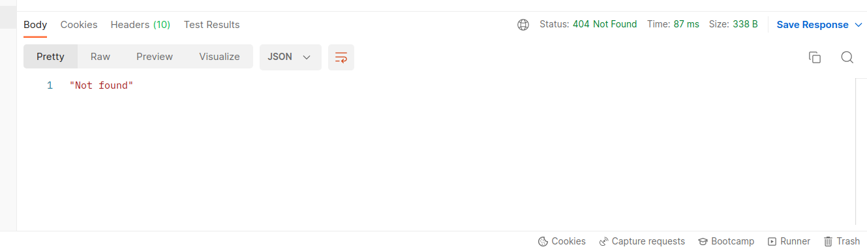

possible status code:
status code | Description
200 Ok | When the product is deleted successfully.
403 Forbidden | When the seller tried to delete other’s product
404 Not found | When the product id no found.
GET products of the Seller
Retreives all the products of the authenticated seller. This includes all products the seller has posted.
A request to fetch a list of products for a seller looks like this:
http://127.0.0.1:8000/ecommerce/seller/product

The response is a list of products objects.
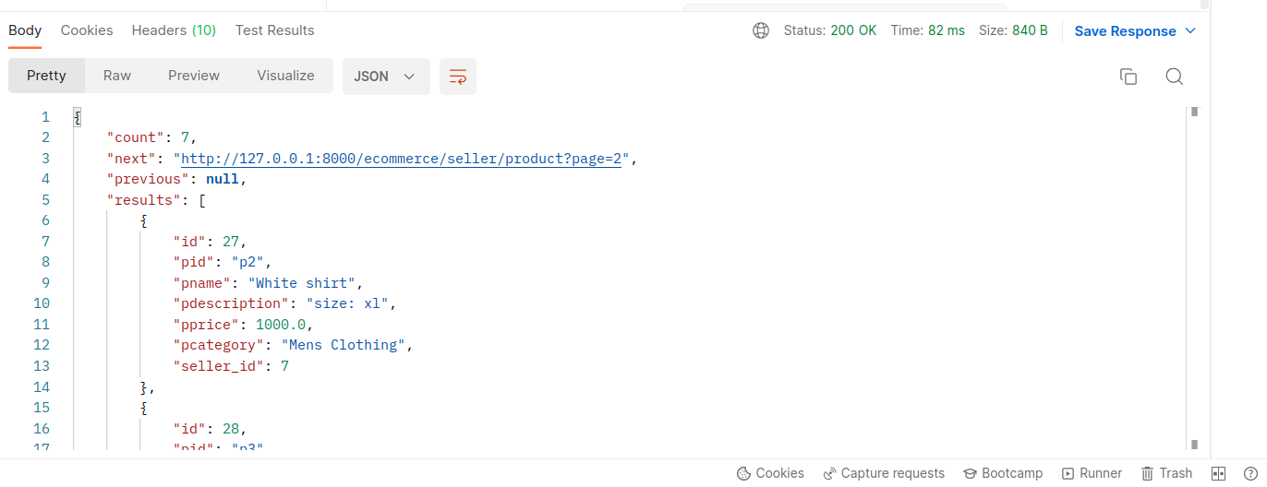

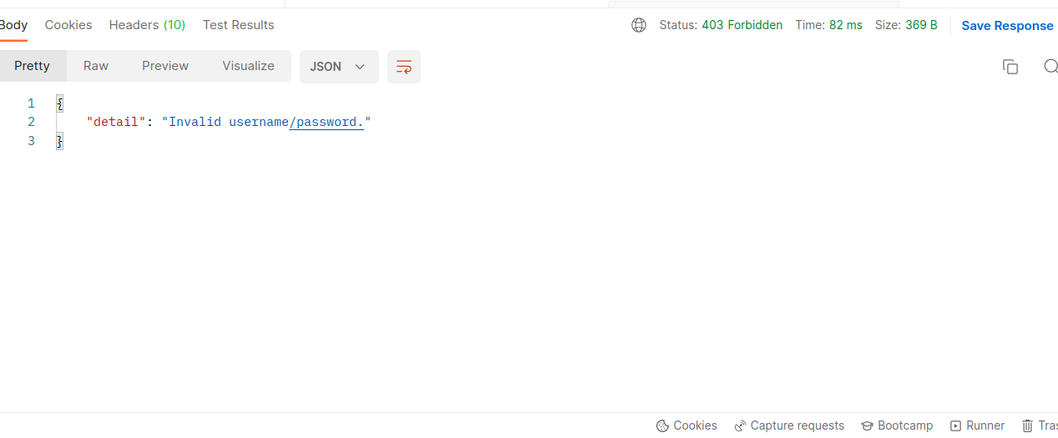

possible status code:
status code | Description
200 Ok | When the product is deleted successfully.
403 Forbidden | When the seller tried to delete other’s product
404 Not found | When the product id no found.

Cart
POST Add cart
the authenticated customers can add the product to their cart.
An example request looks like this:
http://127.0.0.1:8000/ecommerce/cart/add?pid=p1&qty=1
where pid is the product ID and qty is the quantity.
Examples of some Product Ids : p1,p23,P90,KLO90,M90J
Examples of quantity : 1, 2, -1(for decreasing).
An example response looks like this:
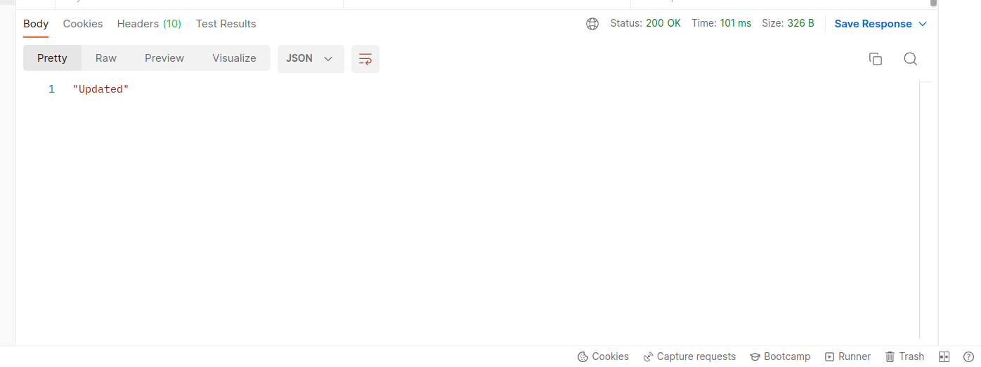

possible status code:
status code | Description
200 Ok | When the request is sucessfull.
201 Created | When the product is add successfully to the cart.
403 Forbidden | When the user is not signed in.
404 Not found | When the product id is not found.

GET cart
the authenticated customers can view their cart.
An example request looks like this:
http://127.0.0.1:8000/ecommerce/cartitems

An example response looks like this:
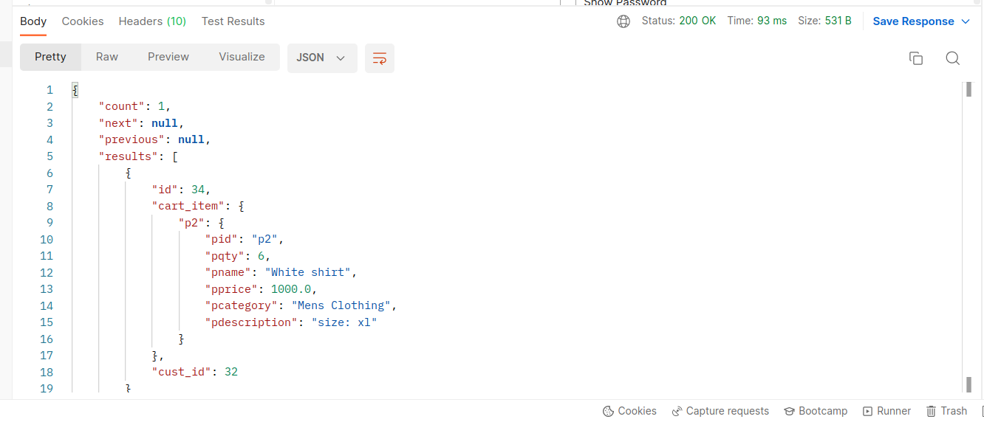

possible status code:
status code | Description
201 Created | When the product is add successfully to the cart.
403 Forbidden | When the user is not signed in.

DELETE cart
the authenticated customers can can delete the products in their cart.
An example request looks like this:
http://127.0.0.1:8000/ecommerce/cartitems/delete?pid=p1
where pid the product ID.
Examples of some Product Ids : p1,p23,P90,KLO90,M90J
An example response looks like this:

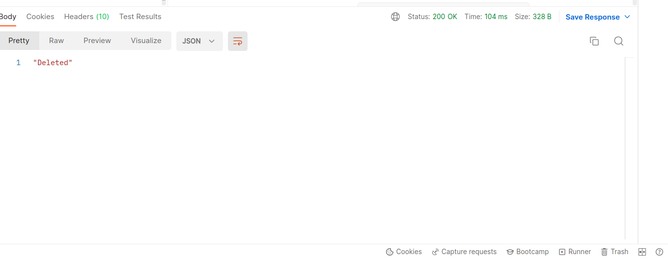

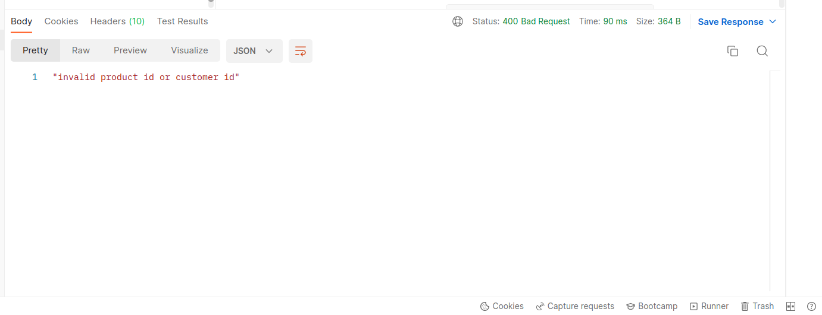

possible status code:
status code | Description
200 Ok | When the product is deleted successfully from the cart.
400 Bad request | When the user id and product is not correct.
403 Forbidden | When the user is not signed in.
404 Not Found | When the product to be deleted is not found in the cart.

